**Automated Phishing Detection in Email Logs**

Example Log file :

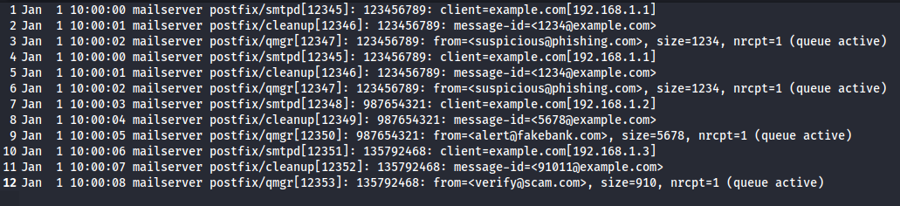

1. How many emails were sent from suspicious sender addresses



1. List all unique suspicious sender addresses that sent emails.

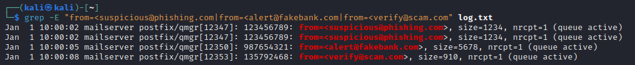

1. What are the timestamps of all phishing emails sent

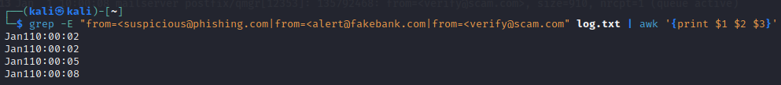

1. Count how many emails were sent from each suspicious sender address



1. Display the details of emails sent from a suspicious, alert and verify sender.

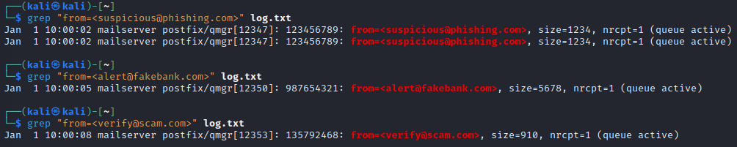

1. Script to get only details of emails sent from a suspicious, alert and verify sender



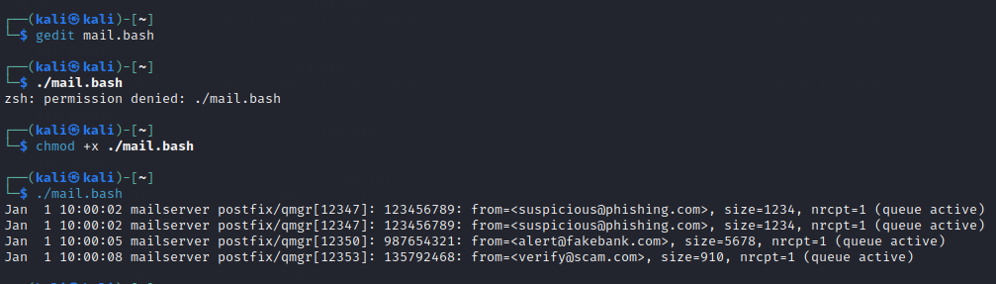

1. Redirecting the details of fraud mails into a file called fraudMails.txt

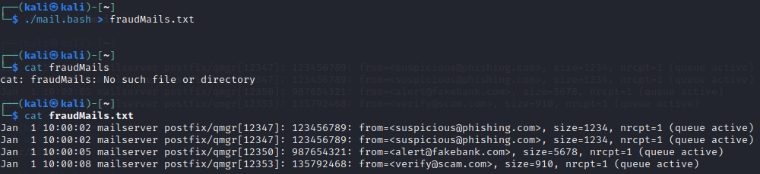

1. Generating the report which contains the types of suspicious email, total phishing emails detected, timestamp of it.

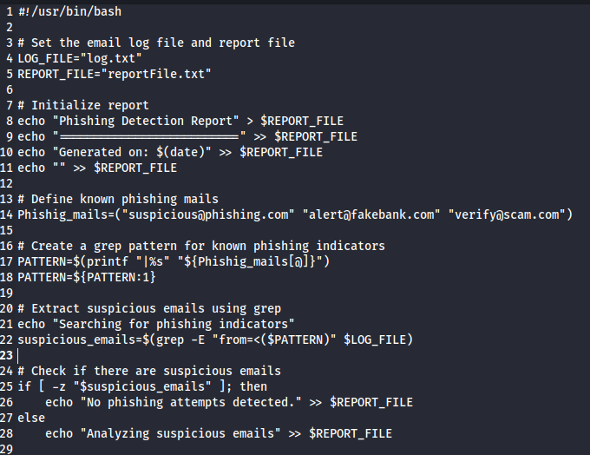

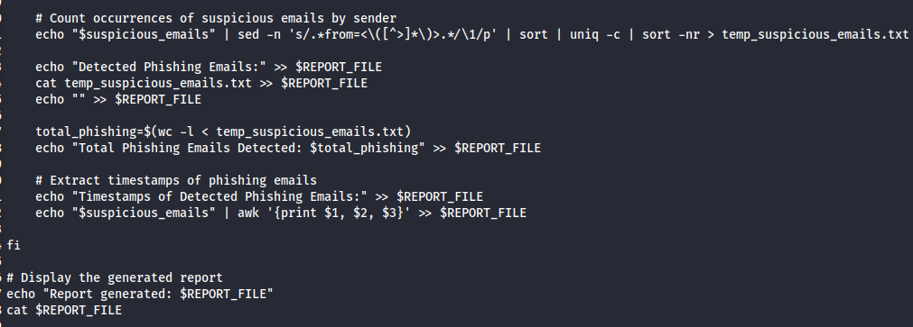

Log.txt



reportFile.txt

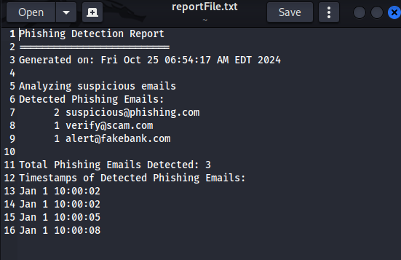

temp_suspicious_mails.txt

